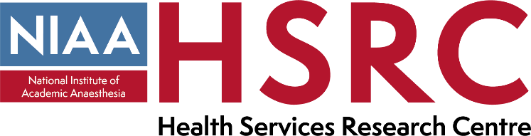

National Institute of Academic Anaesthesia (NIAA),
Health Services Research Centre (HSRC) Deputy Director

Person Specification

Educational Requirements/Qualifications | Essential / Desirable
Full registration with the General Medical Council (without restrictions or warnings) | E
Masters or doctorate (MD or PhD) in a relevant discipline | D

Experience
Holder of a substantive post in a relevant clinical specialty | E
Evidence of expertise in relevant academic discipline(s) (e.g. data science, social sciences, epidemiology, improvement studies) | E
Evidence of relevant research within recent peer reviewed publications | E
Evidence of academic impact (e.g. on policy or clinical practice) | E
Evidence of success in winning research / project funding | E
Evidence of supervising academic students (e.g. fellowship, Masters or doctoral) | D
Evidence of effective academic / porject leadership at local, regional and/or national/international level | E
Familiarity with the national audit structure and processes in the UK | E
Experience of directing and managing a research/project group | E
Proven experience to lead, motivate, inspire and support a multi-professional team and be able to work effectively and sensitively within it | E
Track record of delivering complex projects to time, cost and quality | E
Experience of developing clinical practice guidelines or similar | D
Experience of leading management of change to services | D

Skills and Knowledge
Understanding of the national context and policy issues for the development and delivery of perioperative care | E
Familiar with DHSC and NHSE (+ devolved nations) management and funding structures and knowledge of how to promote change within this context | E
Familiar with methods of developing quality assurance, quality improvement and evidence-based clinical practice and/or public heath practice | E
Understanding of ethical issues in relation to healthcare research and quality improvement | E
Ability to engage in consultative work with external stakeholders | E
Excellent written and verbal communication skills | E
Understanding of methods of research dissemination and knowledge mobilisation | E

Personal Attributes
Ability to work flexibly and independently under pressure and within deadlines | E
Commitment to develop the HSRC in a manner consistent with the aims of the NIAA and RCoA | E
Excellent interpersonal skills in dealing with clinicians, other healthcare workers, managers, College staff and patient and public representatives | E
Ability to respond to changing agendas and priorities | E
Comfortable with dealing with complex issues and direction setting | E
Experienced and comfortable with public speaking and lecturing | E

Organisational Commitment
Support of employing Trust or University | E

